**Project Design Phase-II**

**Technology Stack (Architecture & Stack)**

|  |  |
| --- | --- |
| Date | 31 May 3035 |
| Team ID | LTVIP2025TMID43861 |
| Project Name | Transfer Learning-Based Classification of Poultry Diseases for Enhanced Health Management |
| Maximum Marks | 4 Marks |

**Technical Architecture:**

The Deliverable shall include the architectural diagram as below and the information as per the table1 & table 2

**Example:**

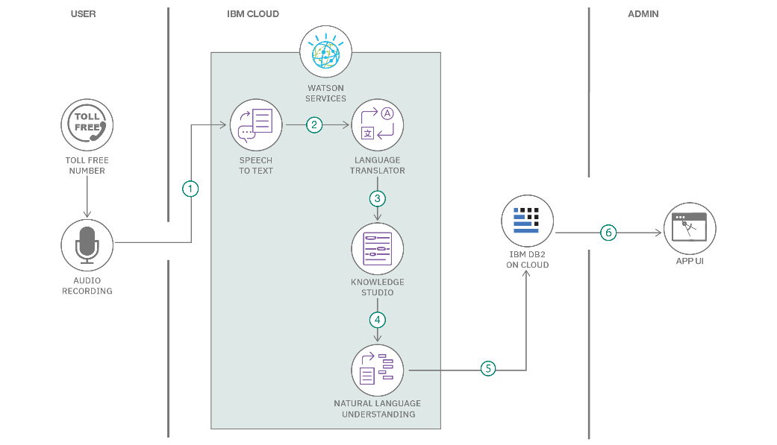**Reference:** [**https://developer.ibm.com/patterns/ai-powered-backend-system-for-order-processing-during-pandemics/**](https://developer.ibm.com/patterns/ai-powered-backend-system-for-order-processing-during-pandemics/)

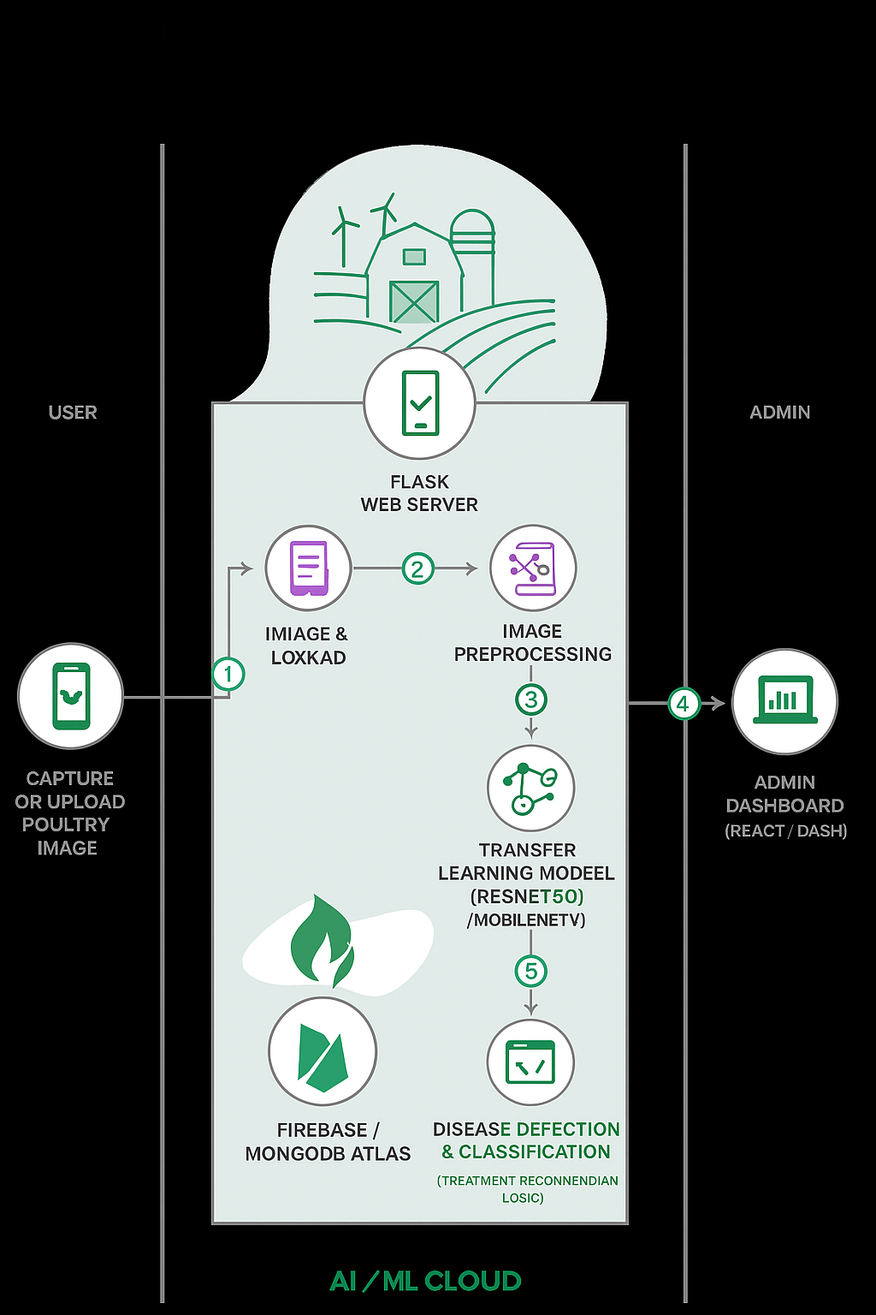

Guidelines:

Include all the processes (As an application logic / Technology Block)

Provide infrastructural demarcation (Local / Cloud)

Indicate external interfaces (third party API’s etc.)

Indicate Data Storage components / services

Indicate interface to machine learning models (if applicable)

**Table-1 : Components & Technologies:**

|  |  |  |  |
| --- | --- | --- | --- |
| **S.No** | **Component** | **Description** | **Technology** |
|  | User Interface | Interface for farmers to upload images and view disease results (Mobile/Web App) | HTML, CSS, JavaScript, React.js, Bootstrap, Android (Kotlin/Java) |
|  | Application Logic-1 | Handles image upload, validation, and preprocessing | Python (Flask), JavaScript |
|  | Application Logic-2 | Logic to send image to ML model and retrieve prediction | Flask REST API / FastAPI |
|  | Application Logic-3 | Logic to handle notifications and database write operations | Python (Flask), Firebase Functions / Node.js |
|  | Database | Stores user data, prediction results, and history | MySQL, NoSQL, etc. |
|  | Cloud Database | Cloud-managed database solution | Firebase, AWS RDS, Google Cloud SQL |
|  | File Storage | Storage for poultry images and model input data | Firebase Storage / AWS S3 / Google Cloud Storage |
|  | External API-1 | Send SMS/Email notification alerts to farmers | IBM Weather API, etc. |
|  | External API-2 | Weather API integration to provide suggestions based on humidity/heat (optional feature) | OpenWeatherMap API / Weatherstack API |
|  | Machine Learning Model | Transfer learning model that classifies poultry diseases from images | TensorFlow/Keras using VGG16, ResNet50, or MobileNet. |
|  | Infrastructure (Server / Cloud) | Deployment of app and model on cloud platform Google Cloud, Firebase Hosting, Heroku, AWS EC2 | Local, Cloud Foundry, Kubernetes, etc. |

**Table-2: Application Characteristics:**

| **S.No** | **Characteristics** | **Description** | **Technology** |
| --- | --- | --- | --- |
|  | Open-Source Frameworks | Project uses open-source tools and libraries for web UI, machine learning, and backend logic. | React.js, Flask, TensorFlow, Keras, Scikit-learn, Firebase (Free tier) |
|  | Security Implementations | Data is encrypted during transit. Secure login mechanisms used. No sensitive data stored on-device. | HTTPS, SHA-256, OAuth2.0 (Gmail login), Firebase Authentication, OWASP Top 10 |
|  | Scalable Architecture | Microservice-like deployment structure: frontend, backend API, ML model service. Can be deployed on scalable cloud platforms. | Flask REST API + Firebase / AWS Lambda + S3 + GCP Storage |
|  | Availability | Hosted on highly available platforms. Uses cloud-based databases and storage, ensuring 24/7 uptime. | Firebase Hosting / Google Cloud Run / AWS EC2 with auto-scaling |
|  | Performance | Model prediction is optimized for real-time results. Caching and CDN can be applied for fast content delivery. Image compression ensures speed. | CDN (Firebase), Model Optimization (e.g., MobileNet), LocalStorage, Caching |

**References:**

[**https://c4model.com/**](https://c4model.com/)

[**https://developer.ibm.com/patterns/online-order-processing-system-during-pandemic/**](https://developer.ibm.com/patterns/online-order-processing-system-during-pandemic/)

[**https://www.ibm.com/cloud/architecture**](https://www.ibm.com/cloud/architecture)

[**https://aws.amazon.com/architecture**](https://aws.amazon.com/architecture)

[**https://medium.com/the-internal-startup/how-to-draw-useful-technical-architecture-diagrams-2d20c9fda90d**](https://medium.com/the-internal-startup/how-to-draw-useful-technical-architecture-diagrams-2d20c9fda90d)